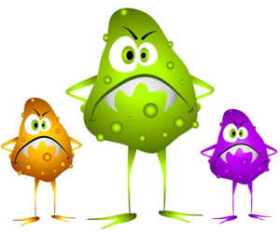
Microbiology Study Guide
- What is the difference between prokaryotic and eukaryotic?
- What 4 things do ALL of cells have?
- What are the characteristics of the organism in each Kingdom?
  - Eubacteria
  - Archaebacteria
  - Protist
  - Fungi
  - Plant
  - Animal
- What are the products and reactants of photosynthesis?
- What are the products and reactants of cellular respiration?
- Where does cellular respiration and photosynthesis take place?
- What is the difference between osmosis and diffusion?
- What are some differences between viruses and bacteria?
- What are the different ways organisms in the Kingdom Protists move?
- What is the difference between a pathogen and a vector?
- What is an example of an infectious disease? A non infectious disease?
- What are some examples of vectors and what diseases are carried by vectors?
- What are some concerns with the overuse of antibiotics and hand sanitizers?
- What are some examples of diseases caused by viruses? Examples of diseases caused by bacteria?
- What organisms are prokaryotic?
- What is a microbe?
- How do hand sanitizers differ from antibiotics?
- What is the difference between a host and a parasite?
- What are the three shapes of bacteria?
- How does bacteria reproduce?
- Why are viruses not considered living things?
- What is a mutagen?
- If a single bacteria multiplies every hour, how long will it take to have 128 bacteria?
- What does an antibiotic do and what is an example of an antibiotic?
- What is an epidemic? A pandemic? Give an example of an epidemic.
- Why is the cell membrane considered semipermeable?
- What is the difference between unicellular and multicellular?
- What some ways that diseases are spread?
- What are some ways to prevent the spread of disease?

Test is Monday, March 26(B day) and Tuesday, March 27 (A day).
